1. We updated our page and our sign in form component

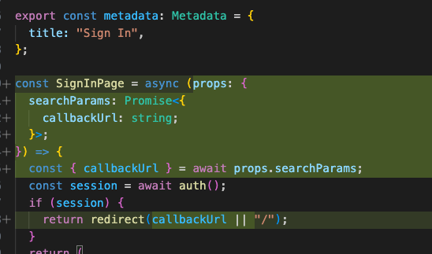

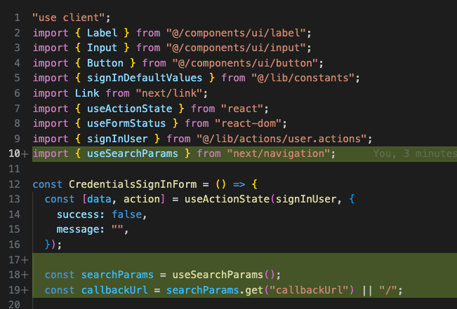



1. Now whenever our URL is like this



Now whenever we sign in with correct creds, we get redirected to the callback URL

THIS IS DONE BECAUSE. LET’S SAY THAT A USER WENT TO CART PAGE WITHOUT LOGGIN IN. BUT THAT’S A PROTECTED ROUTE. SO, USER WILL BE REDIRECTED TO LOGIN PAGE WITH THE CALLBACK URL. NOW WHEN HE LOGINS HE WILL BE REDIRETED TO THE CART PAGE INSTEAD OF THE HOME PAGE.